Exploration Concepts

Wealth: The modern understanding of Wealth is the abundance of valuable resources or material possessions.

Trade: Trade, also called goods exchange economy, is the transfer the ownership of goods from one person or entity to another by getting something in exchange from the buyer. Trade is sometimes loosely called commerce or financial transaction or barter. A network that allows trade is called amarket.

Importing: Import is the act of bringing goods into a country.

Imperialism: Imperialism, as defined by the Dictionary of Human Geography, is "an unequal human and territorial relationship, usually in the form of an empire, based on ideas of superiority and practices of dominance, and involving the extension of authority and control of one state or people over another."^{[2]} It is often considered in a negative light, as merely the exploitation of native people in order to enrich a small handful

Nationalism: Nationalism is a belief, creed or political ideology that involves an individual identifying with, or becoming attached to, one's nation. Nationalism involves national identity, by contrast with the related construct of patriotism, which involves the social conditioning and personal behaviors that support the nation's decisions and actions.

Colonialism: Colonialism is the establishment, exploitation, maintenance, acquisition and expansion of colonies in one territory by people from another territory. It is a set of unequal relationships between the colonial power and the colony and between the colonists and the indigenous population.

Triangle Trade: Triangular trade, or triangle trade, is a historical term indicating trade among three ports or regions. Triangular trade usually evolves when a region has export commodities that are not required in the region from which its major imports come. Triangular trade thus provides a method for rectifying trade imbalances between the above regions.
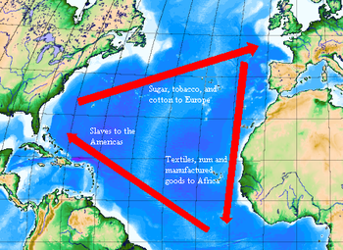

Mercantilism: Mercantilism is an economic doctrine based on the theory that a nation benefits by accumulating monetary reserves through a positivebalance of trade, especially of finished goods. Mercantilism dominated Western European economic policy and discourse from the 16th to late-18th centuries.^{[1]} Mercantilism was a cause of frequent European wars in that time and motivated colonial expansion. Mercantilist theory varied in sophistication from one writer to another and evolved over time. Favours for powerful interests were often defended with mercantilist reasoning.
Or more simply…
- Mercantilism: there is a certain amount of wealth in the world, and it is in the best interest of a nation to accumulate as much as possible.
- Accumulate wealth= accumulate power
- Wealth accumulation => export more than you import and sold at a profit
- Spent little on raw goods, sell a high priced finished good.
- Canada was ripe for the job of raw materials.
- The colony would exist for the benefit of the home country.
- Colonies can only sell to their home country.

