The Life and Times of Oliver Cromwell
Hi there, your task is to create a comic strip outlining the life and times of Oliver Cromwell.
This comic strip should highlight key aspects of his life, and the effect he had on England before, and during the English Civil War.
Use the Library Resources to conduct your research.
http://www.morvenlibrary.org/all-digital-resources.html
In your comic, you may want to focus on the following areas;
- Cromwell’s religious beliefs
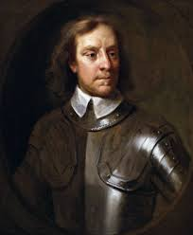
- Cromwell’s relationship with Parliament
- Cromwell’s relationship with King Charles I
- Cromwell’s role as “Lord Protector”
- The Blue Laws
- The New Model Army
- Cromwell in Ireland and Scotland
- His death and legacy

You will be assessed on the following;
10 Marks – Historical Accuracy
5 Marks – Creativity/Artistic Impression

