After having read the account, what questions would you ask to discover the truth at a trial? Make up 4 questions

You are part of the Defense or the Prosecution.
Prepare your side of the argument. Pick your Lawyers, pick your witnesses.
What speech are you going to give to convince the jury of the soldiers’ innocence or guilt?
The only evidence historians have to try and determine Captain Preston's guilt or innocence is the testimony of the eyewitnesses. Unfortunately, many of the statements conflict with each other and with Captain Preston's own account. We must try to piece together a hypothesis from these conflicting sources.

Captain Preston's Account
- Captain Preston claimed he ordered his men to load their weapons.
- Captain Preston claimed he heard the crowd yelling fire.
- Captain Preston claimed they were attacked by heavy clubs and snowballs.
- Captain Preston claimed a soldier was hit by a stick and then fired.
- Captain Preston claimed the other soldiers fired in response to the colonist attack.
- Captain Preston claimed he reprimanded his men for firing into the crowd without orders.
Eyewitness Statements in Support of Captain Preston's Statement
- Witnesses including Peter Cunningham claimed they heard Captain Preston order his men to load their weapons.
- Witnesses including Richard Palmes claimed they asked Captain Preston if he intended to fire and he said no.
- Witnesses including William Wyatt claimed the crowd was calling for the soldiers to fire.
- Witnesses including James Woodall claimed they saw a stick thrown and hit a soldier, which prompted him to fire, quickly followed by several other soldiers.
- Witnesses including Peter Cunningham claimed an officer other than Preston was behind the men and that he ordered the soldiers to fire.
- Witnesses including William Sawyer claimed the crowd threw snowballs at the soldiers.
- Witnesses including Matthew Murray claimed they did not hear Captain Preston order his men to fire.
- William Wyatt claimed that Captain Preston reprimanded his men for firing into the crowd.
- Edward Hill claimed that Captain Preston made a soldier put away his weapon instead of allowing him to continue to shoot.

Eyewitness Statements Opposed to Captain Preston's Statement
- Witnesses including Daniel Calef claimed that Captain Preston ordered his men to fire.
- Henry Knox claimed the soldiers were hitting and pushing with their muskets.
- Joseph Petty claimed he did not see any sticks thrown at the soldiers until after the firing.
- Robert Goddard claimed he heard Captain Preston curse his men for not firing when ordered.
- Several soldiers including Hugh White claimed they heard the order to fire and believed they were obeying his commands.
The facts are unclear. There is some evidence that seems to point to Captain Preston's innocence. Many people close to him did not hear him give the order to fire despite his order to load the muskets. In the confusion of a crowd throwing snowballs, sticks and insults at the soldiers, it would be easy for them to think they received an order to fire.
In fact, as noted in the testimony, many in the crowd were calling them to fire. John Adams defended the soldiers in this case believing that the soldiers deserved a fair trial. Because of the lack of evidence, it is not hard to see why the jury found Captain Preston innocent. The effect of this verdict was much greater than the Crown could ever have guessed. The leaders of the rebellion were able to use it as proof of Britain's tyranny. For example, Paul Revere created a famous engraving that he entitled, "The Bloody Massacre perpetrated in King Street." This was not the only instance of unrest and violence before the revolution, but the Boston Massacre is often pointed to as the event that foreshadowed the Revolutionary War.

Review of Paul Revere’s Engraving
The presence of British troops in Boston had long been a sore point among Boston's radical politicians. Paul Revere wasted no time in capitalizing on the Massacre to highlight British tyranny and stir up anti-British sentiment among his fellow colonists. As you will see, Revere's historic engraving is long on political propaganda and short on accuracy or aesthetics.
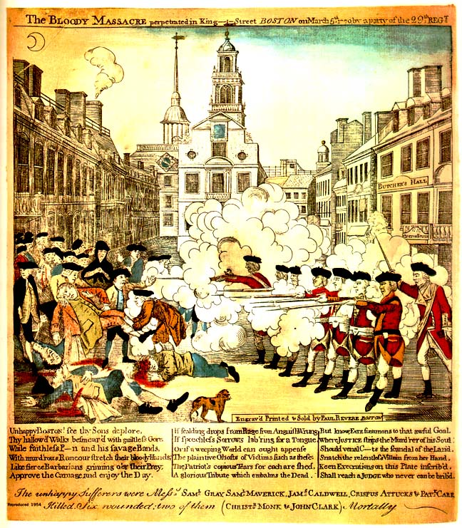
British Grenadiers are shown standing in a straight line shooting their rifles in a regular volley, whereas when the disturbance actually erupted both sides were belligerent and riotous.
Revere's engraving shows a blue sky. Only a wisp of a moon suggests that the riot occurred after nine o'clock on a cold winter night.
There is the absence of snow and ice on the street, while Crispus Attucks — a black man lying on the ground closest to the British soldiers — is shown to be white. As an aside, it should be noted that as a result of his death in the Boston Massacre, Crispus Attucks would emerge as the most famous of all the black men to fight in the cause of the Revolution, and become its first martyr.
Few historians deny that the "Boston Massacre" proved to be a milestone in America's road to independence. By popularizing the tragic event, Paul Revere's print became "the first powerful influence in forming an outspoken anti-British public opinion," one which the revolutionary leaders had almost lost hope of achieving.

